EART33001 – Week 3 Practical: ICP-OES and ICP-MS

Q1) Calculate the frequency and energy (in eV) of green visible light (λ = 550 nm).
Note the following: c_{vac} = 2.998 x 10⁸ m s⁻¹
h = 6.6262 x 10⁻³⁴ J s
1 eV = 1.6022 x 10⁻¹⁹ J
c = λ ν
E = h ν

Frequency ν = c/λ = 2.998x10⁸ / 550x10⁻⁹ = 5.451x10¹⁴ s⁻¹
Energy E = h ν = 6.6262 x 10⁻³⁴ × 5.451x10¹⁴ = 3.61x10⁻¹⁹ J = 2.25 eV

Q2) Hydrogen emission frequencies in the visible region are given by the Balmer series, which is summarised by the following equation:

$$n=3.290 \text{x} {10}^{15 }\left(\frac{1}{4}- \frac{1}{b^{2}}\right); in \left({\text{s}}^{-1}\right) and with b=3,4,5,6,…$$

What are the wavelengths of the first four emission lines?

b = 3; n = 4.57 x 10¹⁴; λ = c/n = 2.998x10⁸ / 4.57 x 10¹⁴ = 656 nm
b = 4; n = 6.17 x 10¹⁴; λ = c/n = 2.998x10⁸ / 6.17 x 10¹⁴ = 486 nm
b = 5; n = 6.91 x 10¹⁴; λ = c/n = 2.998x10⁸ / 6.91 x 10¹⁴ = 434 nm
b = 6; n = 7.31 x 10¹⁴; λ = c/n = 2.998x10⁸ / 7.31 x 10¹⁴ = 410 nm

Q3) Find ν, λ, and k for 2.50 eV photons. (k [wavenumber] = 1/λ).

2.5 eV = 4.0055 x 10⁻¹⁹ J
Frequency ν = E/h = 4.0055 x 10⁻¹⁹ / 6.6262 x 10⁻³⁴ = 6.0449 x 10¹⁴ s⁻¹
Wavelength λ = c/ν = 2.998 x 10⁸ / 6.0449 x 10¹⁴ = 496 nm
Wavenumber k = 1/λ = 2.02 x 10⁶ m⁻¹ = 2.02 x 10⁻³ nm⁻¹

Q4) Find c_{H2O} and λ_{H2O} of sodium light (λ_{air} = 5893 A) at 25ºC.
The refractive index (n_{H2O}) of water at this wavelength and temperature is 1.33.
Assume that the frequency is the same in both media. Recall that: $n_{H2O}=\frac{c_{air}}{c_{H2O}}$

c_{(H2O)} = c_{(air)}/n_{(H2O)} = 2.998 x 10⁸ / 1.33 = 2.25 x 10⁸ m s⁻¹
Frequency ν_{(air)} = c_{(air)}/λ_{(air)} = 2.998 x 10⁸ / 5893 x 10⁻¹⁰ = 5.09 x 10¹⁴ s⁻¹ ≈ ν_{(H2O)}
λ_{(H2O)} = c_{(H2O)} / ν_{(H2O)} = 2.25 x 10⁸ / 5.09 x 10¹⁴ = 4.43 x 10⁻⁷ m = 443.1 nm

Q5) The track pitch (or groove spacing t) on a DVD is 0.74 μm. Visible light covers the wavelength range between approximately 0.390 and 0.700 μm. The diffraction grating equation is: nλ = t . sin α, where n = order of diffraction.
At what range of angles would you detect diffraction maxima from visible light off a DVD surface (use an order of diffraction of 1)?

sin⁻¹ (0.39/0.74) = 31.8° and sin⁻¹ (0.70/0.74) = 71.1°

Q6) Below is a table of strong optical emission lines, masses of the different isotopes, and percent mass abundances for the different isotopes for 8 common metals in environmental systems.
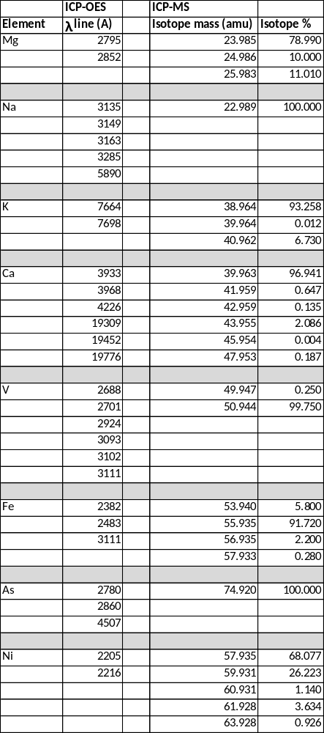
Determine where there may be problems with spectral overlap for these elements in an ICP-OES instrument with a 10 A spectral resolution?
Similarly, determine where there may be isobaric interferences causing potential issues for ICP-MS analyses using a quadrupole ICP-MS with a 1 amu mass resolution.

ICP-OES – Possible interferences:
Mg at 2852 A and As at 2860 A
V at 3111 A and Fe at 3111 A

ICP-MS – Possible interference:
⁴⁰K at 39.964 and ⁴⁰Ca at 39.963
⁵⁸Fe at 57.933 and ⁵⁸Ni at 57.935

Q7) In the spreadsheet labelled “Fluid Analyses”, along with the data for the Rio Tanama problem, there are two sheets of data, one for ICP-OES analyses of calibration standards and an unknown, and one for ICP-MS analysis of calibration standards and a different unknown. Note that errors for these types of analyses are usually given as 3σ, that is, ± 3 x standard deviation.

a) Calculate calibration curves for ICP-OES and determine whether the linear relationship holds.

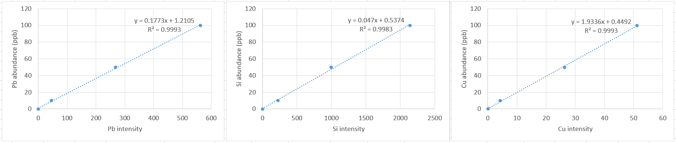

Plotting standard analyses as unknown shows linear calibration holds for the 3 elements.

b) Give the concentrations in the unknown analysed by ICP-OES with error bars.

c) Using the mean of 3 runs for each standards, calculate calibration curves for ICP-MS analyses of ²⁹Si, ⁶³Cu, ⁶⁵Cu, ²⁰⁶Pb, and ²⁰⁸Pb and determine whether the linear relationship holds for each calibration. An acceptable calibration should have a correlation coefficient R² > 0.95.

If there are species for which it does not hold, what could be the cause(s)?
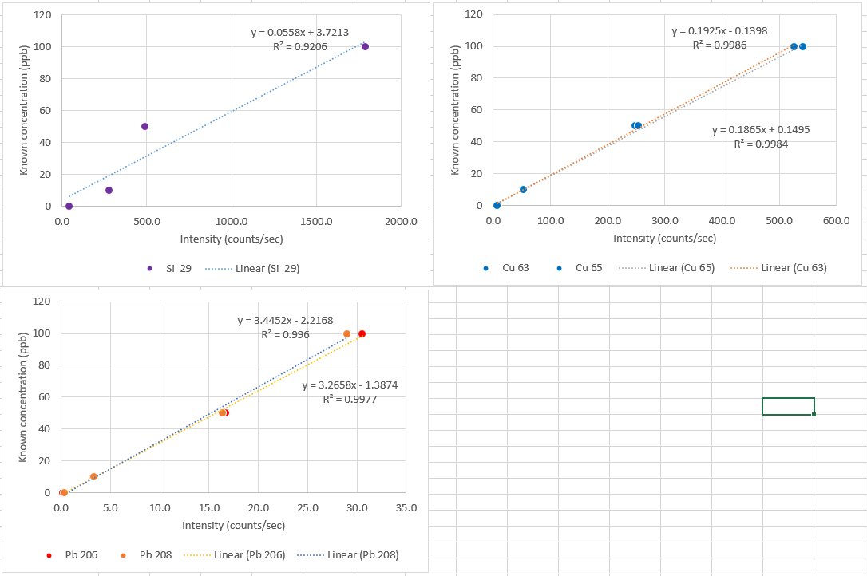

Plotting standard analyses shows linear calibration holds for the 2 isotopes of Cu and Pb, as calibration lines have R² > 0.99. Linear calibration does not hold for Si, indicated by low R² of 0.92.

This is because the torch of the ICP-MS is made of silica, making ICP-MS analyses of Si imprecise. So we typically analyse Si using ICP-OES. In this case, the sensitivity of ICP-MS is both an advantage and a problem compared to ICP-OES.

d) Give the concentrations in the unknown analysed by ICP-MS with error bars.

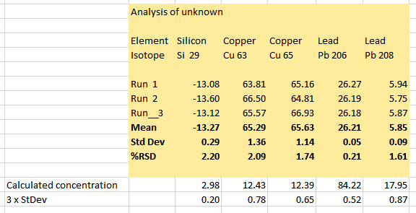

e) There appear to be some complications concerning some of the ICP-MS data. Discuss those complications and give possible explanations for them.

Along with the Si analysis problem in the ICP-MS analysis discussed above (exemplified here with negative intensity for 29Si), there is also a discrepancy in the Pb abundance results. The isotope ²⁰⁶Pb gives 84 ppb, while analysing the isotope ²⁰⁸Pb gives 18 ppb. This is probably because the ²⁰⁶Pb/²⁰⁸Pb isotope ratio in the analysed sample does not match the known relative abundance of isotopes ²⁰⁶Pb and ²⁰⁸Pb in natural Pb. Therefore, because ²⁰⁶Pb is a radiogenic isotope produced by radioactive decay of ²³⁸U, and since the Pb abundance calculated using ²⁰⁶Pb is higher than that calculated using ²⁰⁸Pb, this analysis suggests that the fluid has been in contact with elements that are part of the ²³⁸U decay chain. This is in fact the case.

